# Project Design Phase-I Solution Architecture

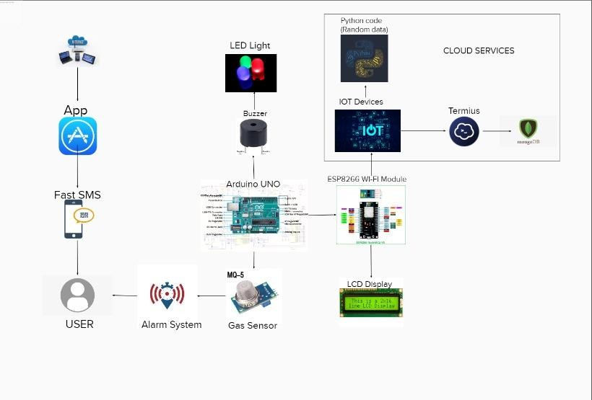

|  |  |
| --- | --- |
| Date | 30 September 2022 |
| Team ID | PNT2022TMID34760 |
| Project Name | Gas Leakage Monitoring And Alerting System |
| Maximum Marks | 4 Marks |

**Solution Architecture:**

Solution architecture is a complex process – with many sub-processes – that bridges the gap between traffic problems and technology solutions. Its goals are to:

* To replace the static signboards, smart connected sign boards are used.
* These smart connected sign boards get the speed limitations from a web app using weather API and update automatically.
* Based on the weather changes the speed may increase or decrease.
* Based on the traffic and fatal situations the diversion signs are displayed.
* Guide(Schools), Warning and Service(Hospitals, Restaurant) signs are also displayed accordingly.
* Different modes of operations can be selected with the help of buttons.

# Solution Architecture Diagram: